HOW TO USE

PROJECT NAME: STUDENT GUIDENCE PORTAL

TEAM MEMBERS:

1. JITENDRA PANWAR
2. ABHISHEK GOYAL
3. TUSHAR LAKHOTIA

THIS IS A PROJECT WHICH ACTS AS A INFORMATIVE CONTENT.

TO USE THE PROJECT FIRST OF ALL YOU WILL HAVE TO SERVE IT ON LOCALHOST:4200.

AFTER THE SERVE THE PAGE WHICH OPENS IN FRONT OF US JUST LIKE…

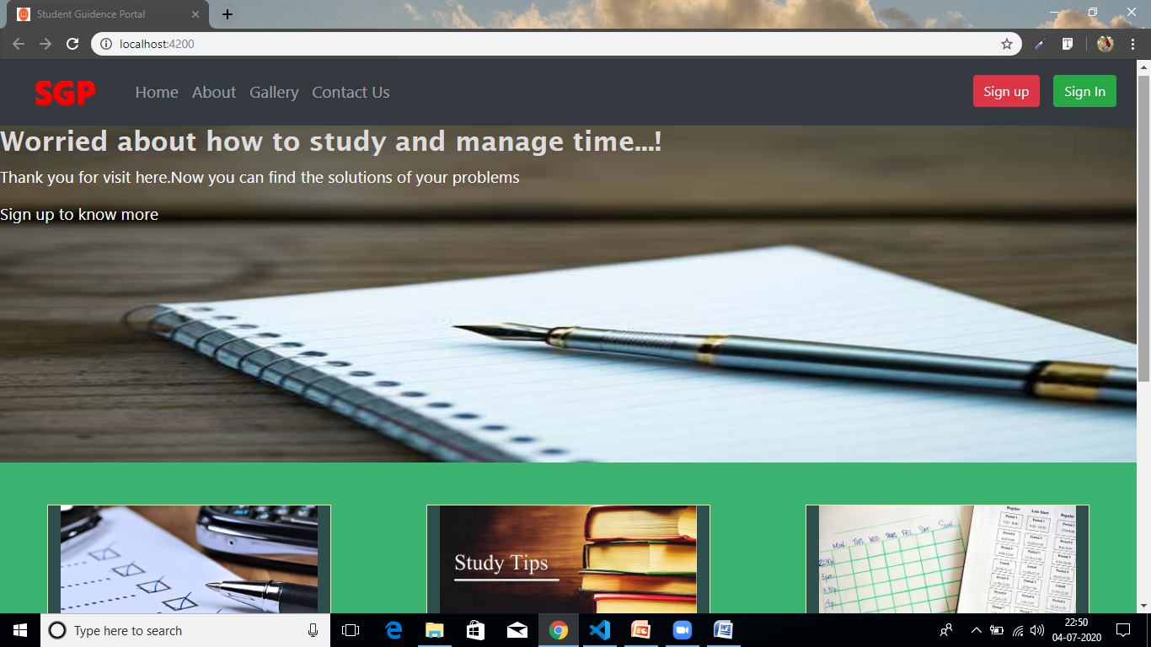

NOW CLICK ON SIGN UP BUTTON IF YOU ARE NEW USER AND HAVE NOT CREATED ACCOUNT BEFORE.ELSE CLICK ON SIGN IN BUTTON IF HAVE ALREADY AN ACCOUNT.

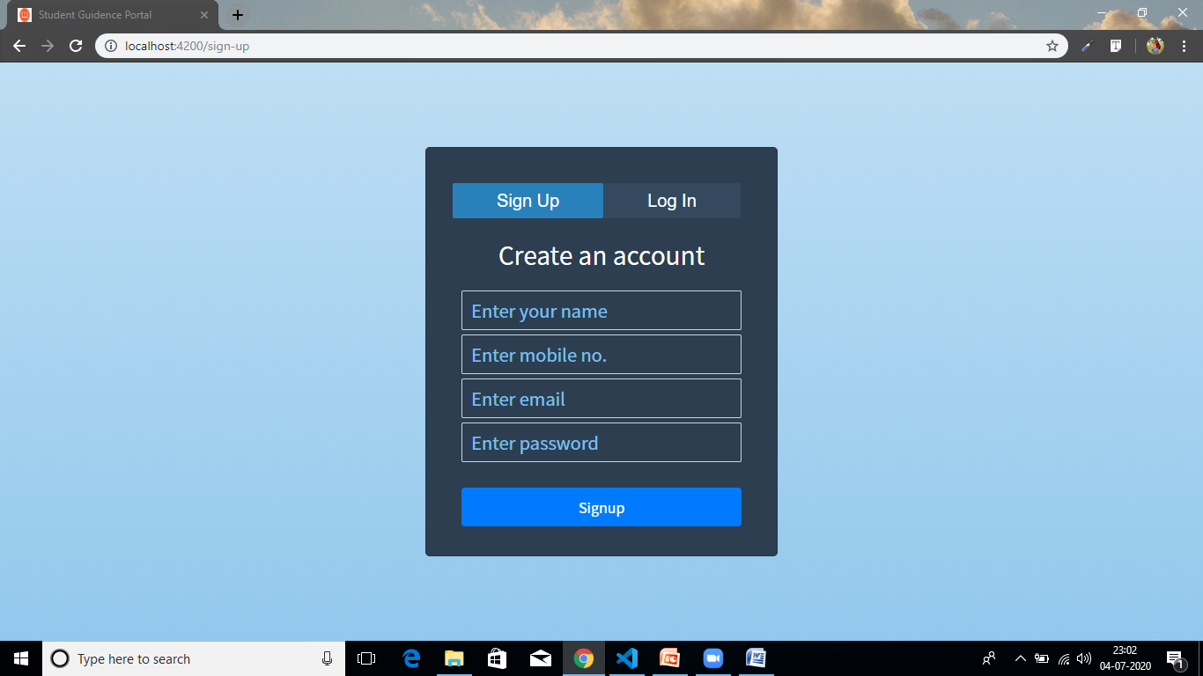

HERE FILL ALL THE FIELDS AS MENTIONED AND CLICK ON SIGNUP BUTTON,IT WILL REDIRECT YOU TO SIGNIN FORM.

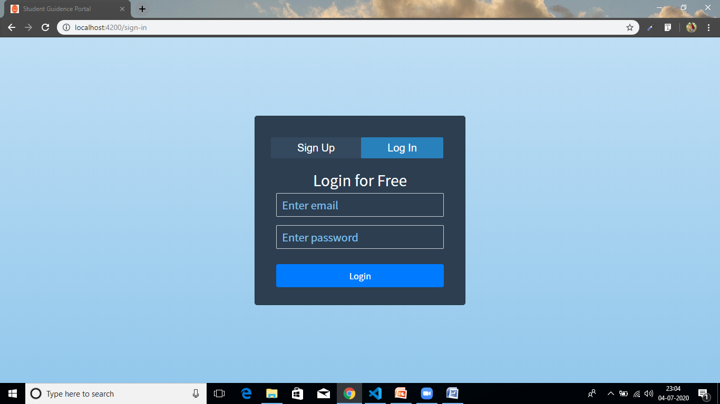

HERE AGAIN FILL THE FIELDS AND CLICK ON SIGNIN BUTTON.IF YOUR ENTERIES ARE VALID THEN YOU WILL BE REDIRECTED TO DASHBOARD PAGE.

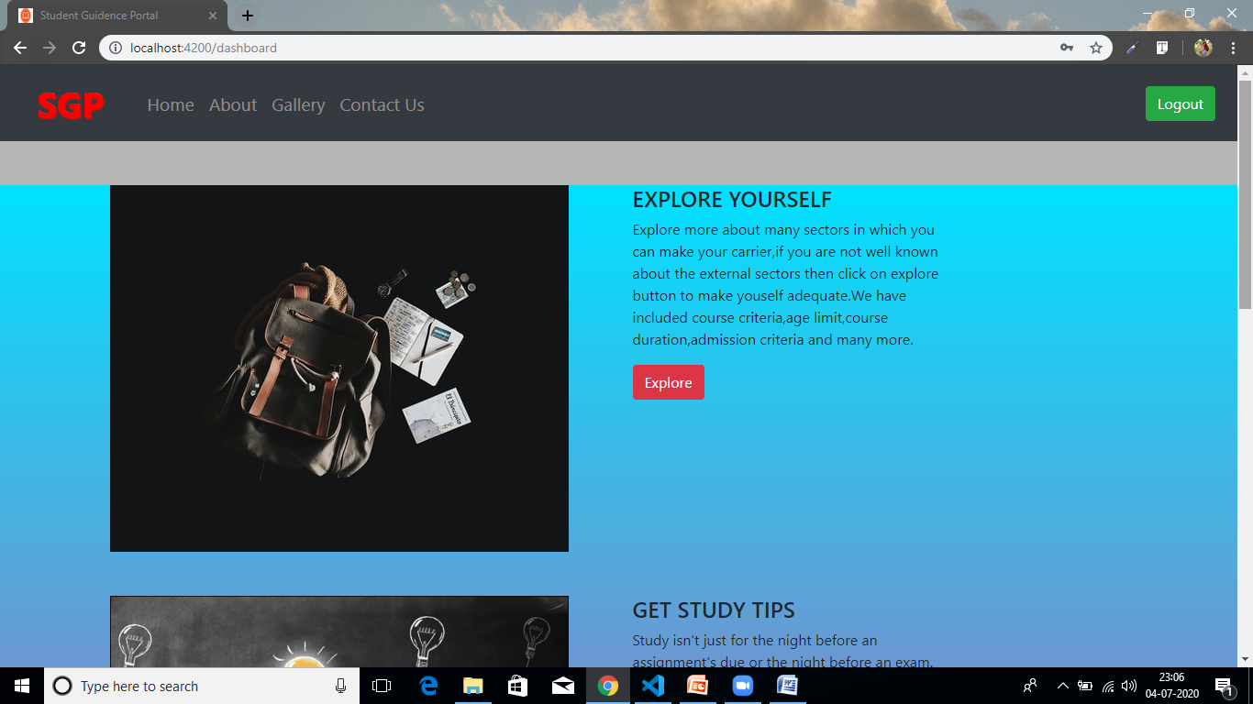

THIS IS THE DASBOARD PAGE WHICH CONTAINS THE INFORMATIONS.

IF YOU HAVE ANY KIND OF QUERY THEN CLICK ON “CONTACT US” BUTTON AND AFTER THAT FILL THE ENTERIES.

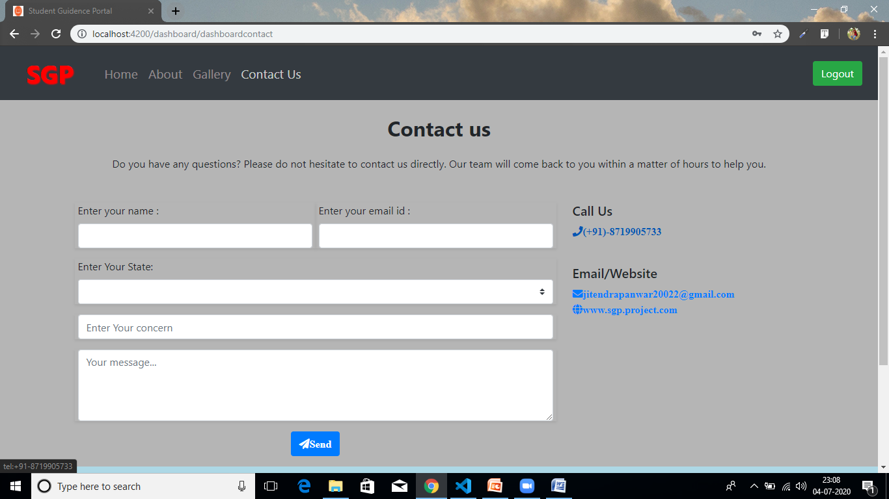

TO EXPLORE THE EXTERNAL FIELDS GO ON EXPLORE BUTTON…

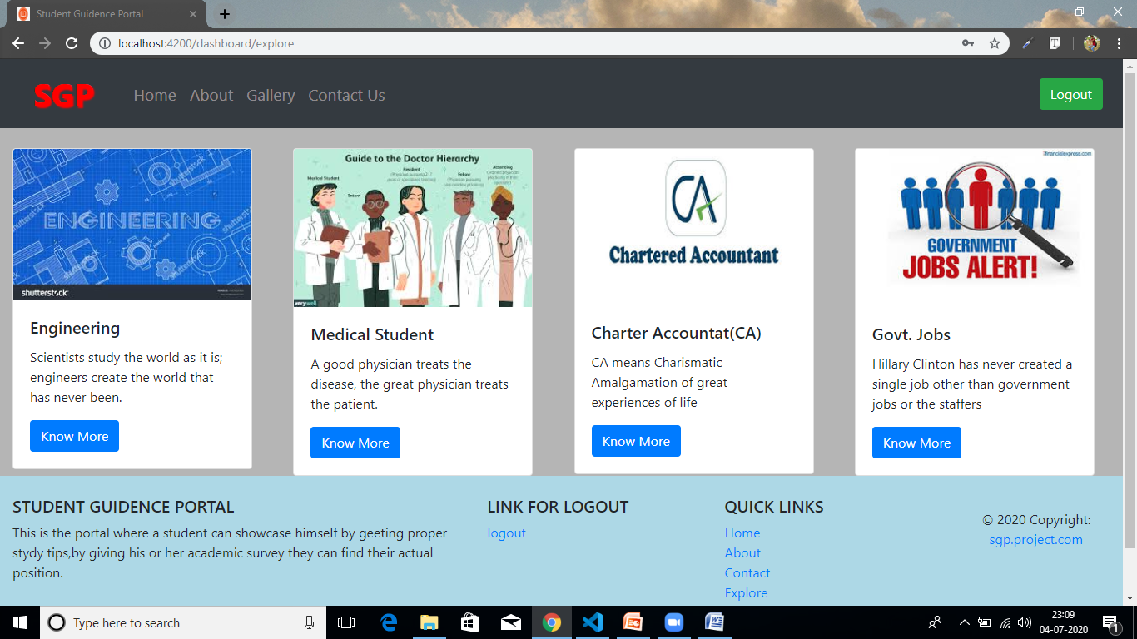

TO READ THE STUDY TIPS GO ON GET BUTTON…

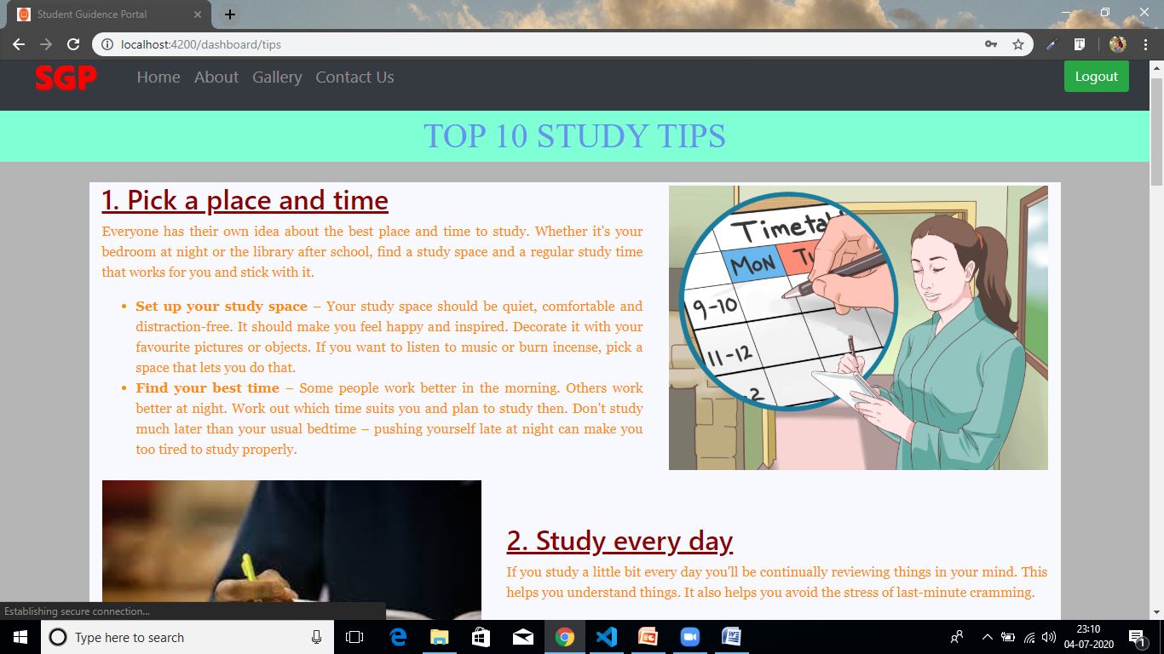

TO SCHEDULE A TIME TABLE GO ON CREATE BUTTON…

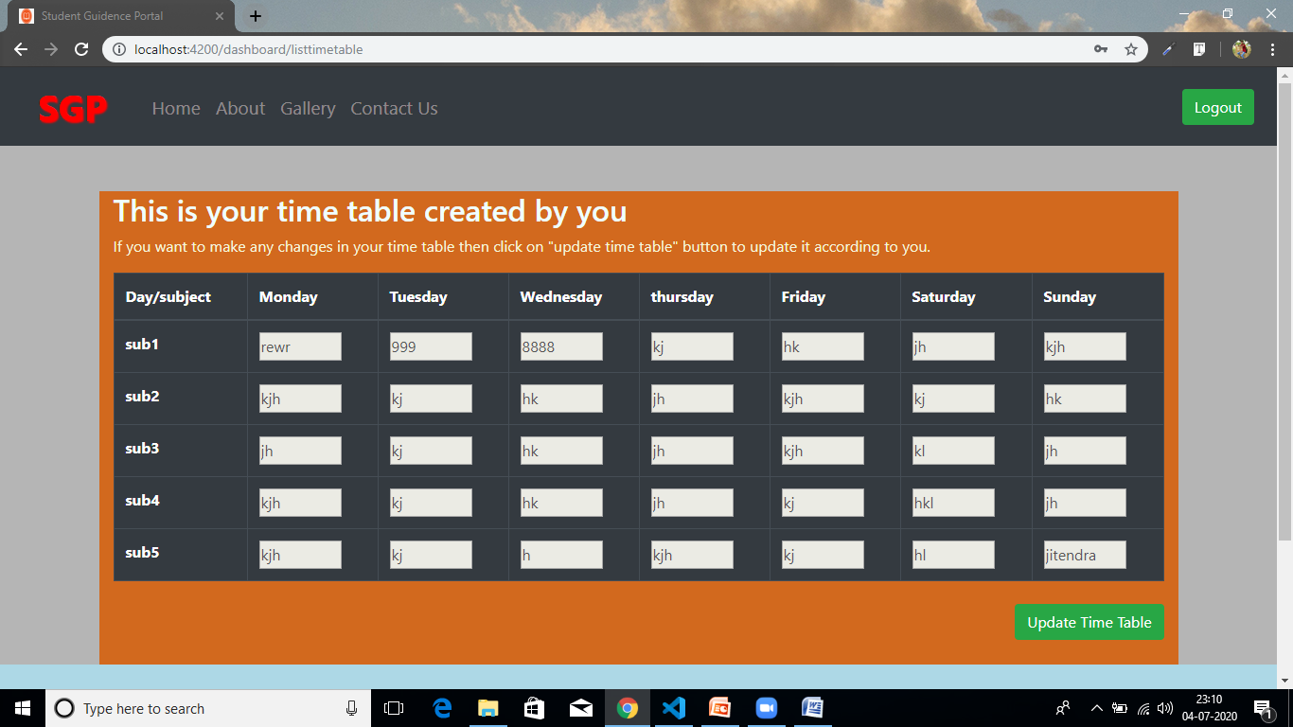

IF THERE IS ANY KIND OF CHANGES IN TIME TABLE THEN CLICK ON UPDATE TIME TABLE BUTTON.

TO COME OUT FROM DASHBOARD PAGE CLICK ON LOGOUT BUTTON IT WILL AGAIN REDIRECT YOU TO MAIN PAGE.

